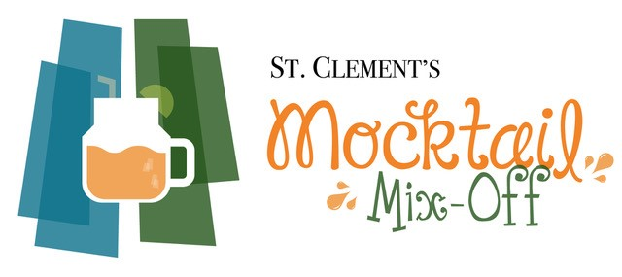
REGISTRATION FORM

Team Name: Click or tap here to enter text.
Contact Person:
Name: Click or tap here to enter text.
Phone Number: Click or tap here to enter text.
Email Address: Click or tap here to enter text.
Category:
Community Group
Business
Family/Friends

Event Information:
The Mocktail Mix-Off will take place under the big tent at Lynn Valley Park on Saturday, June 22 at 1:30 pm. All teams are asked to report in by 1:15pm.

Entry Details:
Please submit all entries by Friday, June 21 at 5 pm. Registration will be closed earlier if all slots are filled, so please submit your entry ASAP! Email entries to peggy@stclementschurch.ca.

A voluntary entry fee of $5 will be gratefully accepted at the event, and put toward St. Clement's support of addiction and recovery services in Lynn Valley.
Questions? Call Peggy at 604-619-5576.

