Meditation Pathways

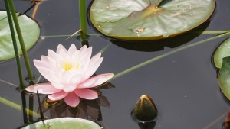

** Beginning January 19, 2019 **

RELAX … your body;
STILL … your mind;
LEARN TO BE PRESENT …in the moment

Saturdays: 11:00 am to noon
Location: St John’s Anglican Church (chapel)
Drop in: $3.00 per session
Facilitator: Deacon Juanita

Beginners: this group is for YOU!

Each session will offer: a relaxation exercise, a 5 minute address, explore a variety of meditation pathways (including the use of mantras, sacred readings, lectio and audio divina, chanting, prayer beads etc.) before entering into a ‘sit’. The group will begin with a 10 minute ‘sit’ …gradually building up to 30 minutes, over the weeks, as the skill and comfort level of participants grows. Geared for busy people, please join us as spirit moves you and your schedule allows.

St. John the Evangelist Anglican Church
220 West 8th Street, North Vancouver, BC V7M 1N1
604-986-1151; Email: deaconjuanita@telus.net
Website: www.stjohnnv.ca

