Saturday, October 27: 10am – 3.30pm
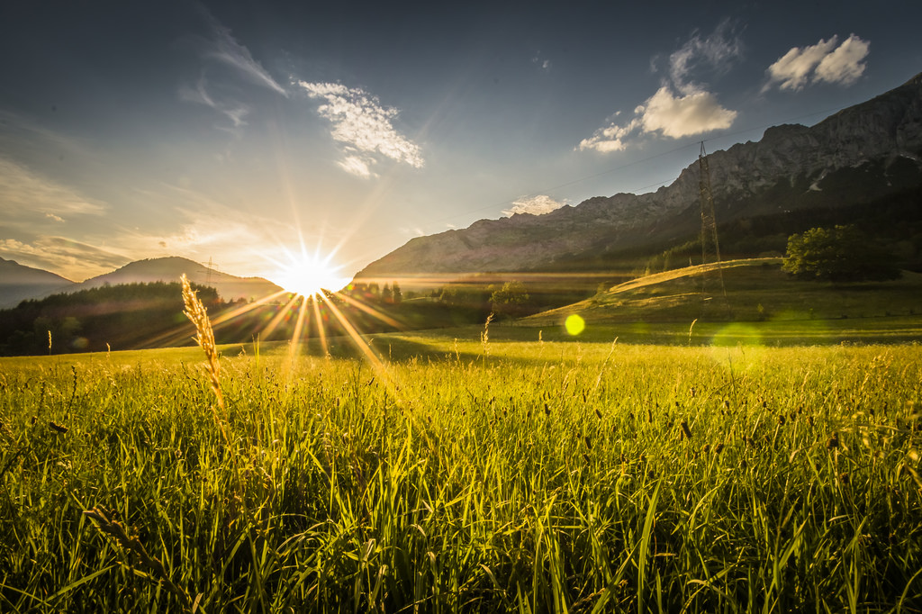

“Christ and the
Sundance”

*What is the Sundance?
*What are the similarities between
Christianity and the Sundance?

Salmon and Bannock lunch
(donations welcome)

Venue: St Clement’s Anglican Church
3400 Institute Road, North Vancouver

